My code for my sticky footer

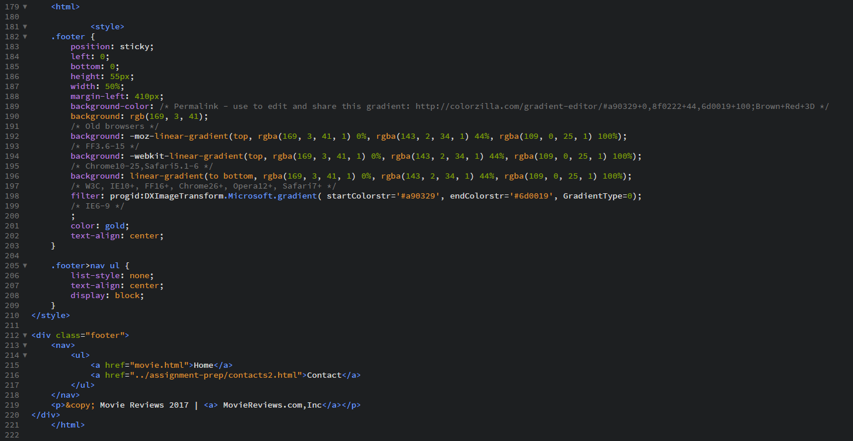

How my footer looks when window is at full screen

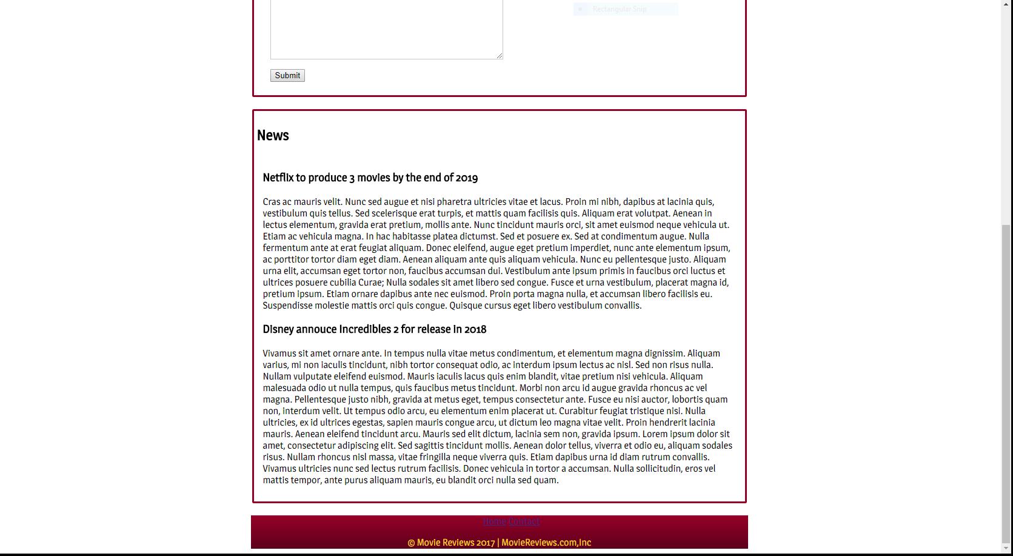

Just wanted to point out how difficult it is to see the nav buttons, because of the colour

*[Grab your reader’s attention with a great quote from the document or use this space to emphasize a key point. To place this text box anywhere on the page, just drag it.]*

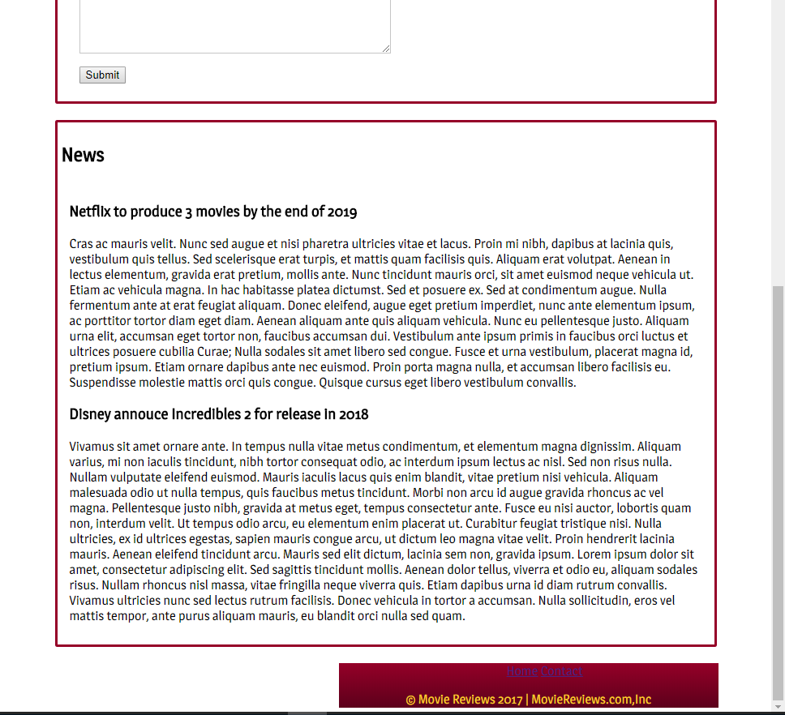How my footer looks when window Is resized